**Purpose of the Guide:**

**To help user replace laser module**

**\*This guide also works for Moai 200. Moai 200 has a different laser module than Moai 130.**

-

Before we start, make sure you have the protection glasses ready and wear it before testing laser.

Below is a diagram of the laser / glavo mount. The screw above the laser secures the module. By loosening that screw, you can slide the laser module out of the mount.

Before doing so, make sure the system is powered off.

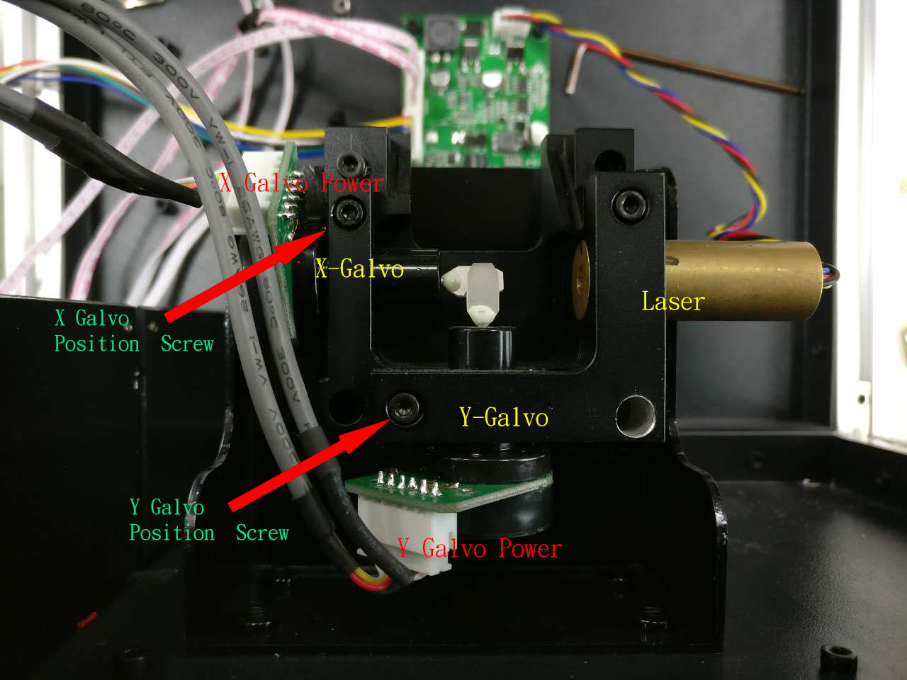

The steps are:

1. Disconnect the laser power cable from the board
2. Loosen the screw above the laser module on the mount so that you can slide out the module.
3. Put the new laser module in the same spot as the old laser module. Make sure the tip of the laser is aligned to the mount, like in the above picture. This helps ensure the focus distance. Tighten the screw above the module to secure.
4. Run the ring-test print to make sure the laser power level is consistent as previous laser